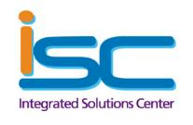

The Information below represents the volume of ISC related Support tickets submitted by your organization.

Please review this information and if you have any questions, feel free to call the ISC at ext. 5-4727 and ask to speak to someone regarding the Maximize Dashboard.


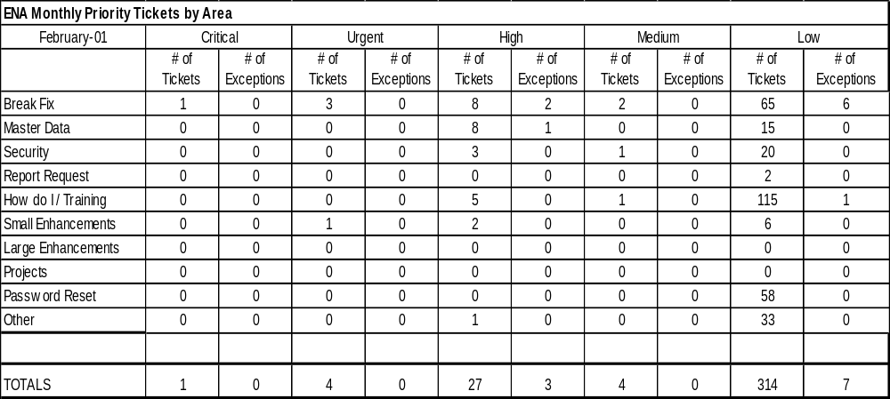
# of
Tickets
# of
Exceptions
# of
Tickets
# of
Exceptions
# of
Tickets
# of
Exceptions
Break Fix
805
0
576
0
785
430
Master Data
536
0
395
0
385
212
Security
472
0
0
0
472
440
Report Request
58
0
44
0
30
13
How do I / Training
92
0
281
0
513
215
Small Enhancements
112
0
88
0
94
52
Large Enhancements
19
0
13
0
14
5
Projects
0
0
0
0
0
0
Password Reset
0
0
450
0
410
177
Other
0
0
273
0
229
93
TOTALS
2094
0
2120
0
2932
1637
October
November
December
Three month rolling report of results

